FormFactor (FORM)
Category: Test Equipment (Consumable)
Est. Price Per Unit: $75k - $150k per MEMS Probe Card

What They Do

Product 101 and Where They Fit into the AI Stack
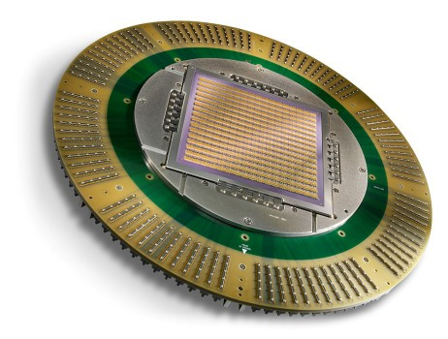
FormFactor is the largest global player in probe cards. While they compete with Technoprobe in logic, they are the dominant leader in memory testing (DRAM/Flash) and maintain a diversified portfolio across the semi ecosystem.
The key distinction is logic vs. memory:
Logic (Technoprobe's turf): complex, high speed, high heat. Checking calculations. CPUs, GPUs, AI accelerators.
Memory (FormFactor's turf): volume, repetition, parallelism. Memory chips are commodities—you want to test 500 at a time, not one.
FormFactor builds massive MEMS probe cards that touch and test hundreds of memory chips simultaneously. This is a different engineering problem than Technoprobe's high-pin-count logic cards.
They offer a broader product set vs. Technoprobe's depth.

Alignment with Overall Thesis
HBM is the tailwind. High Bandwidth Memory stacks DRAM vertically to feed AI GPUs. It's harder to test than standard memory, requires Known Good Die testing (can't stack 8 layers if the bottom one is broken), and volume is ramping as SK Hynix, Micron, Samsung feed Nvidia's demand.
Important distinction from Camtek: Camtek uses cameras to find visible errors (bumps look straight). FormFactor uses probes to find functional errors (can the memory actually store and retrieve data). You need both.

Business Model, Customers
$75k-$150k per card. Consumable model—cards are "ink cartridges" for testing. Recurring based on touchdowns (volume).
Core customers are memory IDMs (SK Hynix, Micron, Samsung). Also serves logic, but Technoprobe has been gaining share in high-end logic.
More diversified than Technoprobe (memory, logic, R&D systems), which provides stability but also more exposure to memory cyclicality.

Comments on Team
Founded in 1993; founder no longer in company.
Standard US corporate structure, unlike Technoprobe's family dynasty. Led by Mike Slessor (CEO)—focused on M&A, supply chain optimization, steady diversified growth.

Early View of Moat Hypothesis
Memory testing dominance. Engineering for testing 500 chips simultaneously is non-trivial.
Breadth of portfolio makes them a one-stop shop for fabs that don't want multiple vendors.
Scale and supply chain leverage—larger than Technoprobe.

Why They're Interesting, and Why Now
HBM is the near-term catalyst. Memory makers are scrambling to ramp production, every stack needs Known Good Die testing, and FormFactor is the incumbent.
We have to believe HBM shortage persists and FormFactor defends its position as testing complexity increases.
Diversification provides downside protection vs. pure logic plays, but also means more memory cycle exposure.

Key Risks
Memory cyclicality. When memory prices crash, capex freezes. FormFactor is more exposed than Technoprobe.
Market share loss in logic—Technoprobe has been gaining in high-end logic. FormFactor needs to defend.
Being the "supermarket" can mean lower margins and less pricing power than a specialist.

Gaps in Understanding / Key Questions
How much of the HBM tailwind is priced in? Is memory dominance durable as HBM complexity increases?
What's the real market share trajectory in logic vs. Technoprobe? Ceding high-end or defending?
How differentiated is HBM probe card engineering vs. standard DRAM?

Select Financial Graphs

R1: Total Revenue & YoY Growth
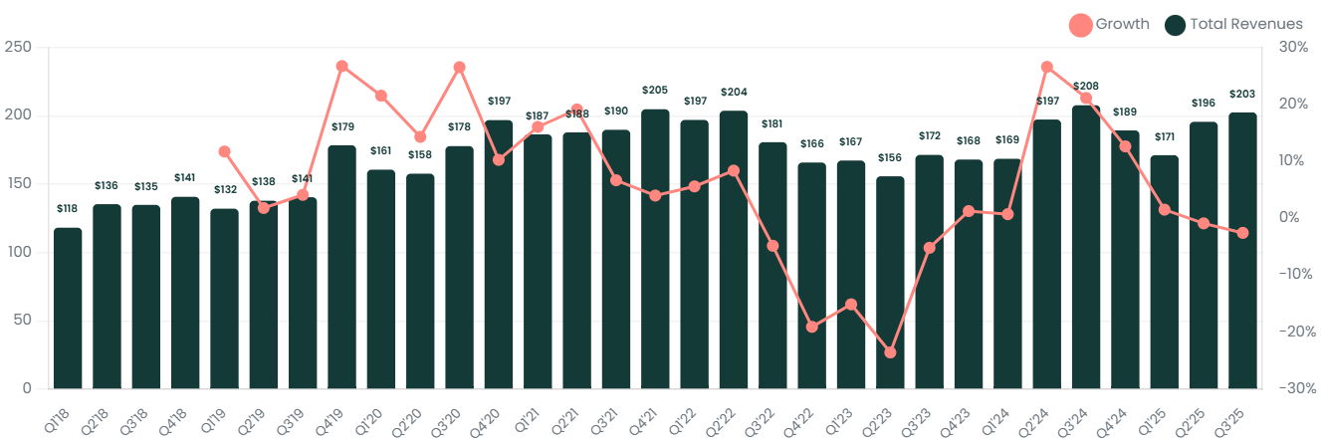

I1: Inventory Turns
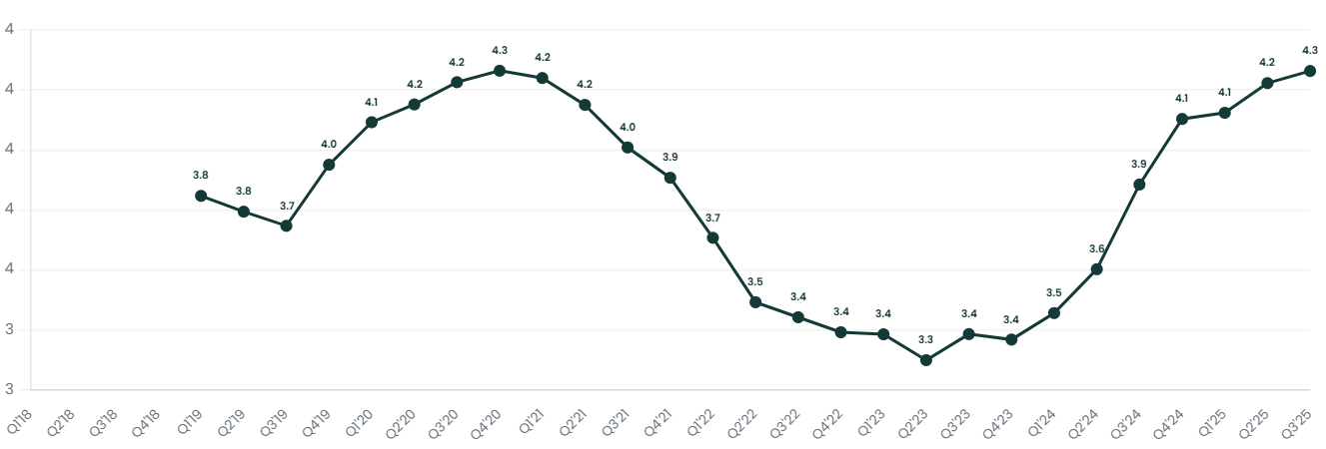

P4: Operating Margin
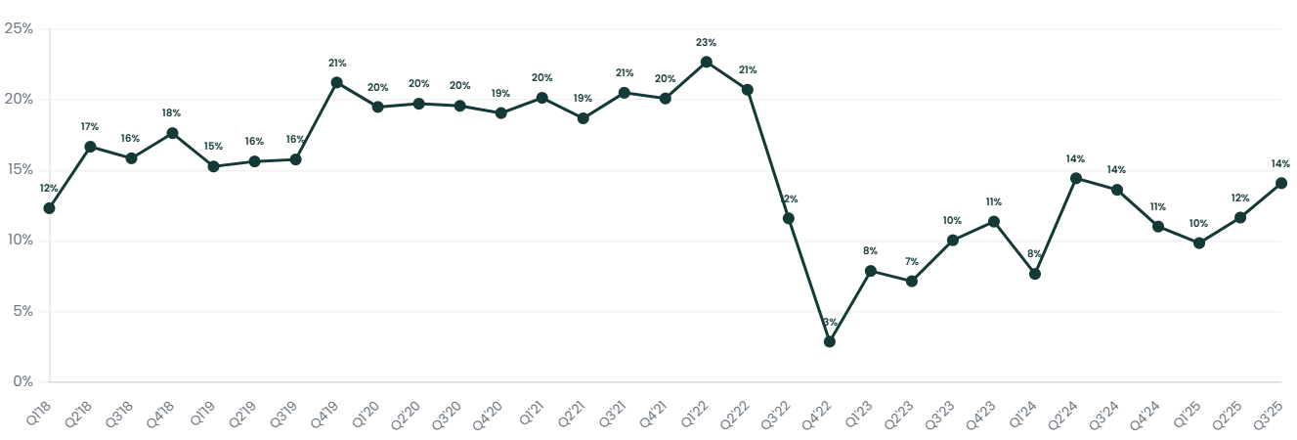

S2: End Market Mix
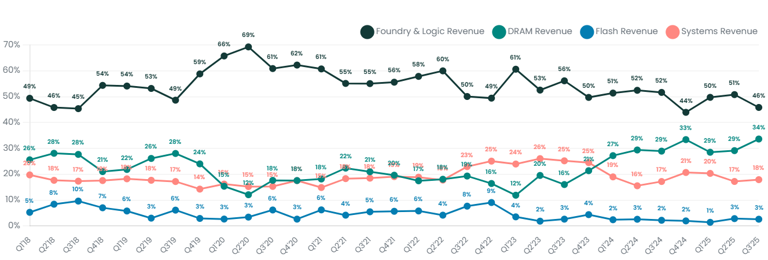

V1: EV/Sales NTM
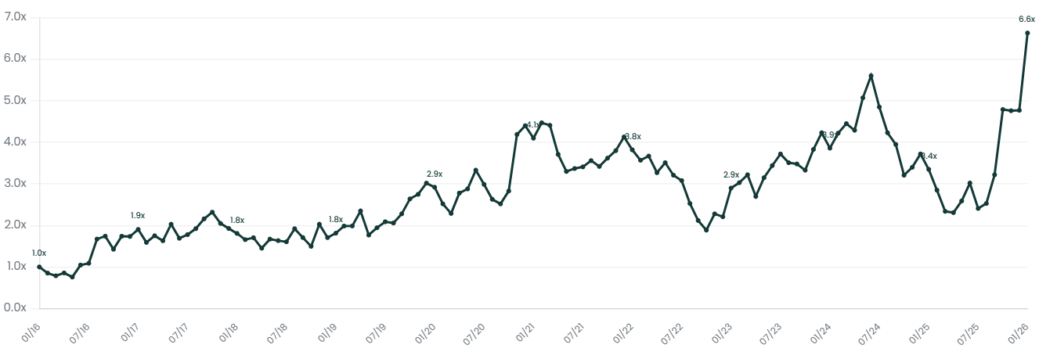

Interesting Topics to Read
FormFactor vs. Technoprobe competitive dynamics
HBM probe card requirements vs. standard DRAM
Memory testing parallelism (multi-die probing)
Known Good Die (KGD) for HBM stacks
Memory cycle history and probe card demand correlation

